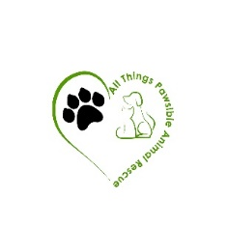
ALL THINGS PAWSIBLE ANIMAL RESCUE
OWNER SURRENDER FORM
305-785-2818

I ______________________ give ownership of One (Color)______________________

(Breed)_____________________________________ Named:__________________________ to

All Things Pawsible Animal Rescue on this date: __ /__ /__.

I am no longer responsible for this dog and All Things Pawsible Animal Rescue

will be responsible party for _______________________________________________.

To the best of your knowledge has this dog bitten in the past 6 months?

No:_____ Yes (please explain):______________________________________________________

Good with kids?:________other dogs?:____________ cats?:_____________________________

Any additional info you feel would be helpful:_________________________________________

______________________________________________________________________________

_____________________________________________________________________________

Veterinary Information:___________________________________________________________

______________________________________________________________________________

Owner’s Signature:_____________________________________________________ Date:__ /__ /__

Owner’s Full Name:_______________________________________________________

Address:________________________________________________________________

